**Q Cloud**

**Create one Bucket in root user**

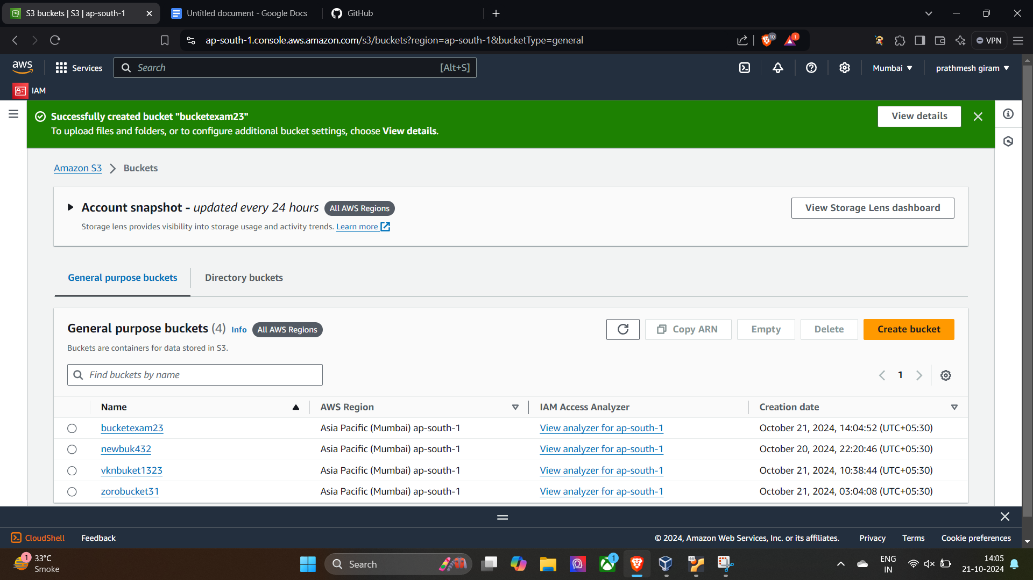

**Create one user**

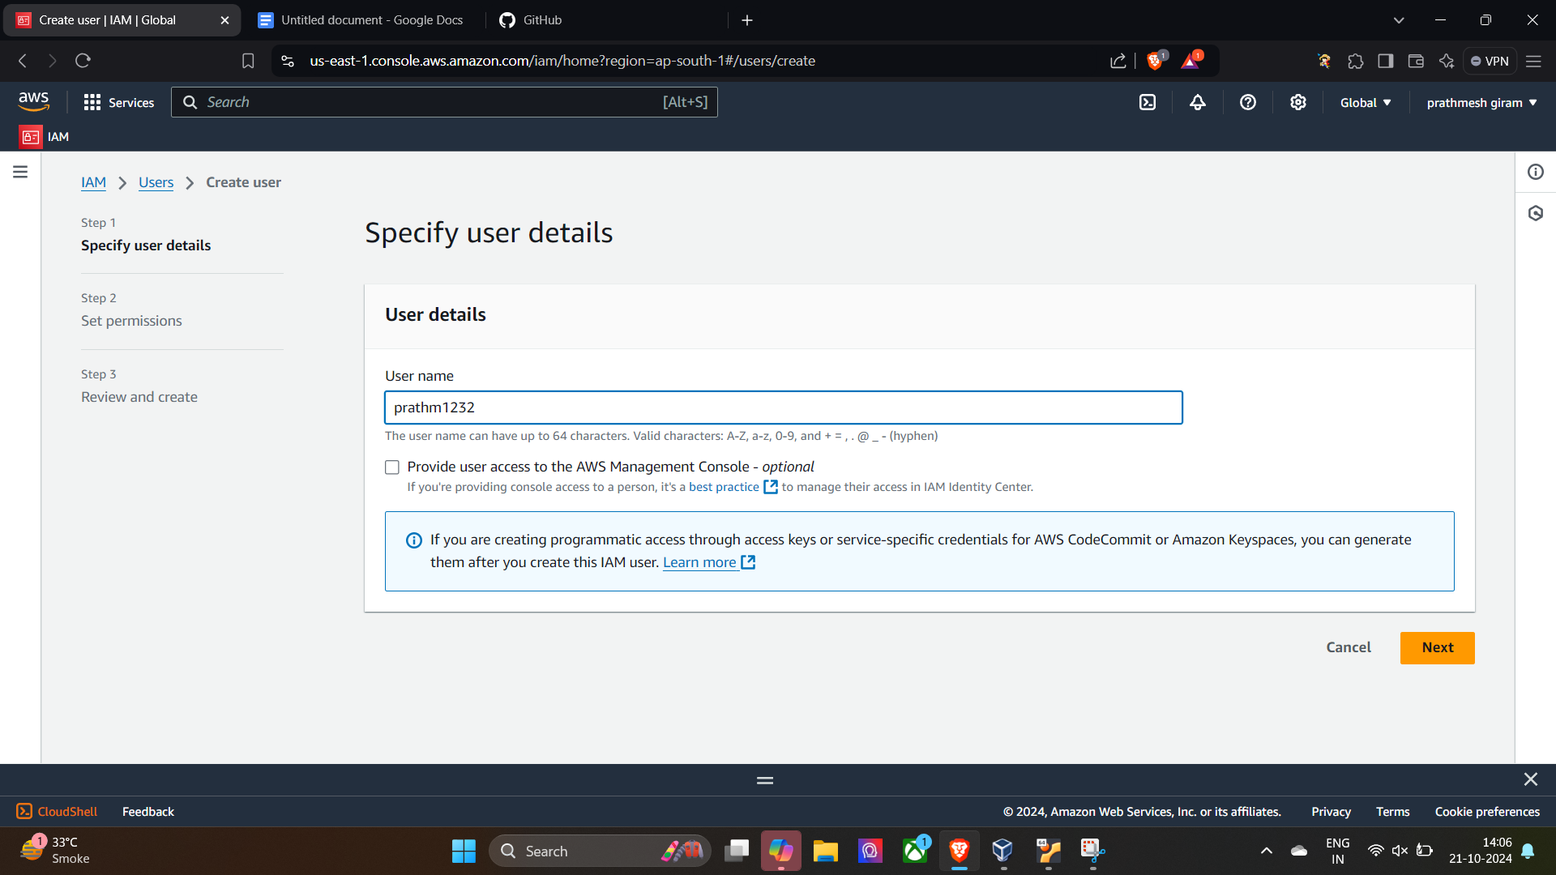

**Give the Ec2 full access**

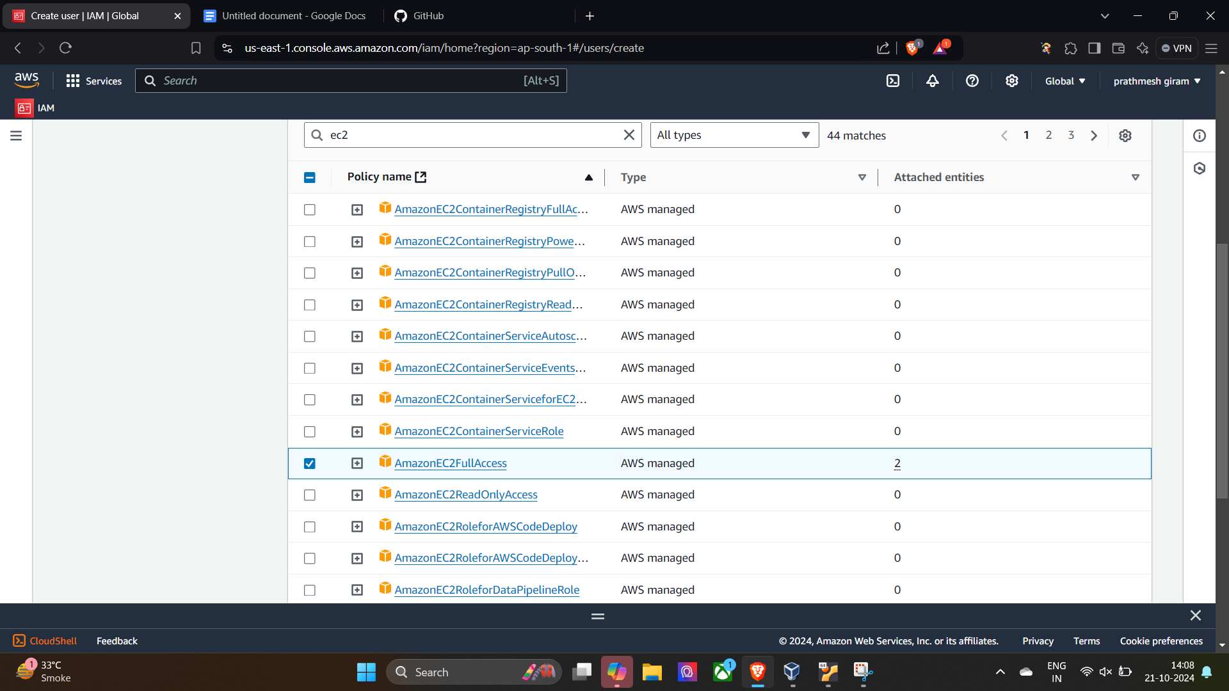

**Give the s3 full read only access**

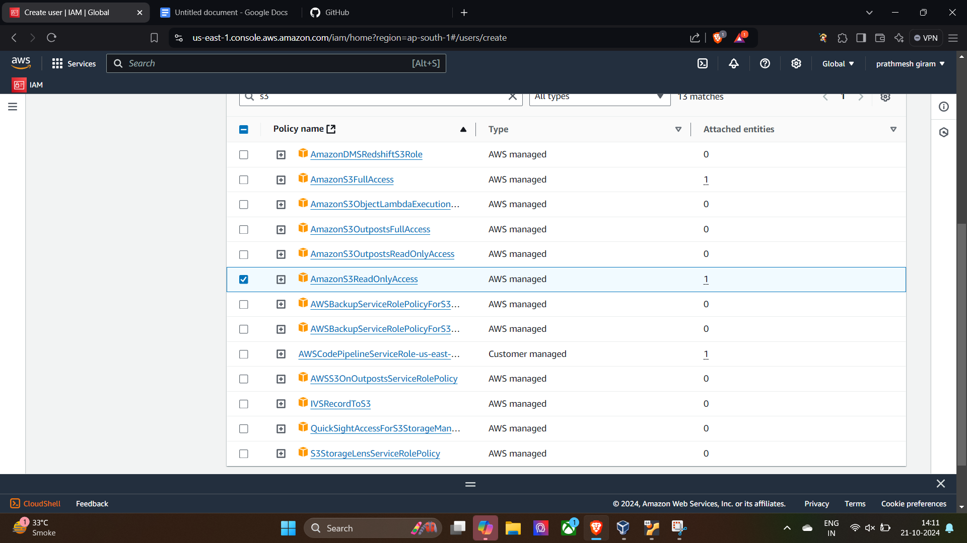

**User created**



**Enable the console access for the Iam user**

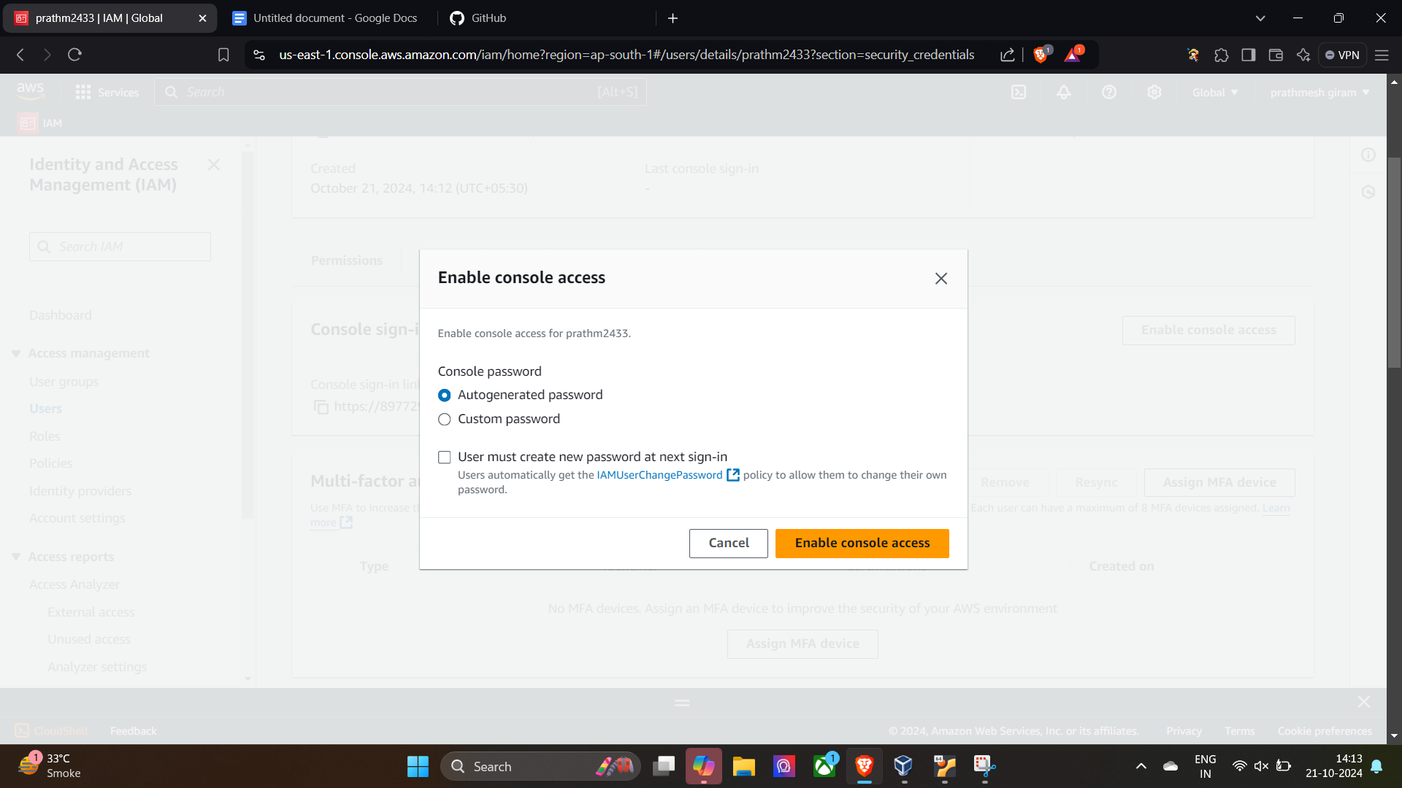

**Download the Csv File**

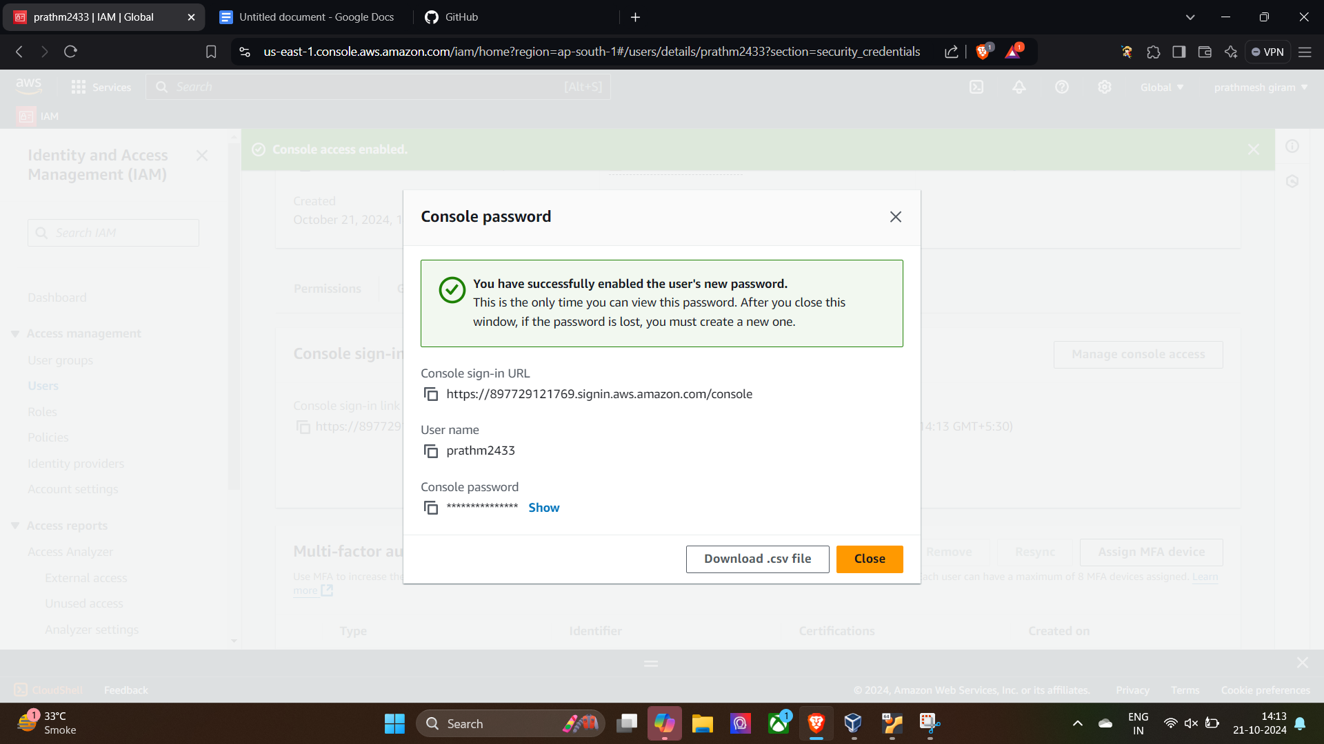

**Create one access key for the iam user**

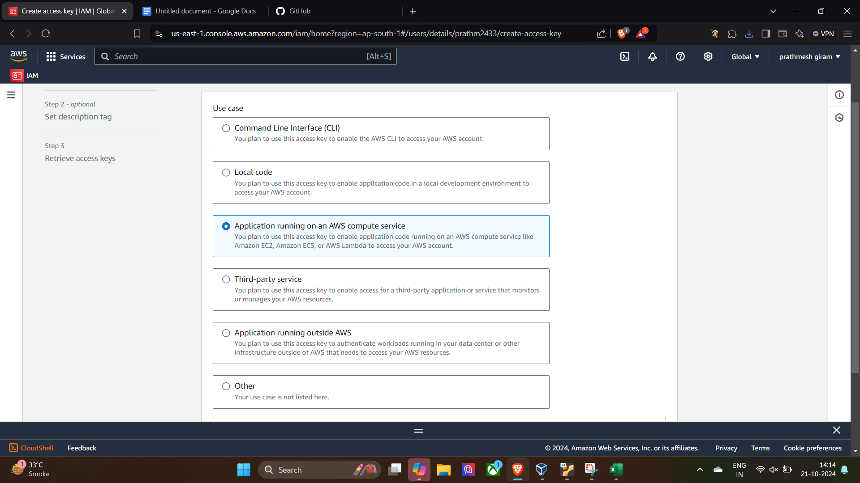

**Open i am user with the url in security crenditials**

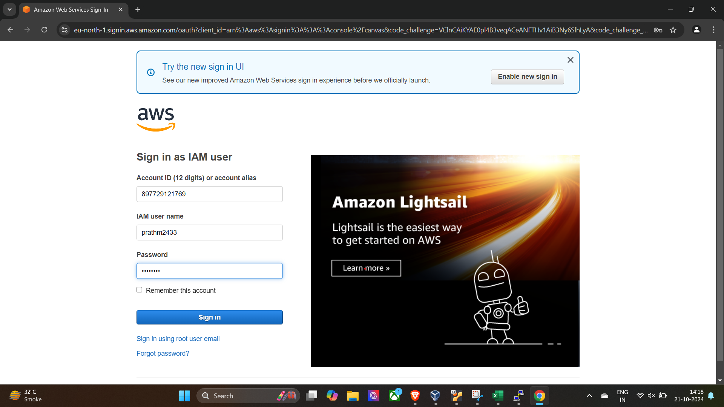

**Create instance in it**

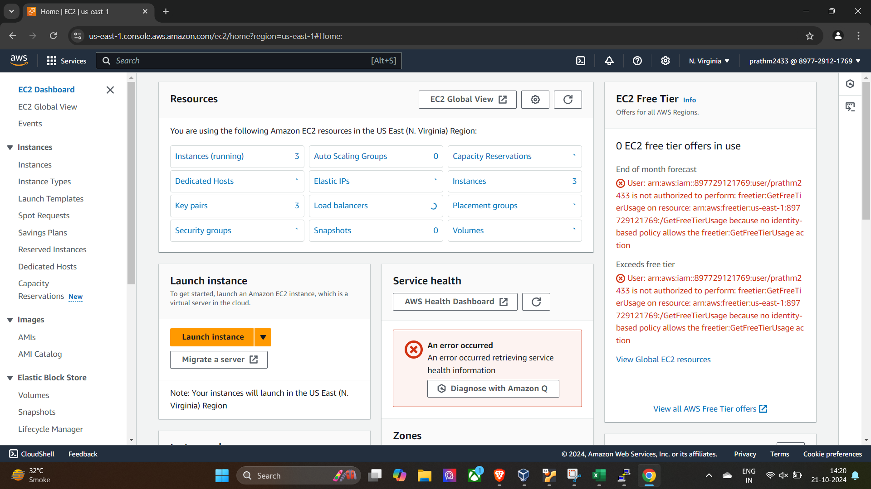

**Create one key for the instance**

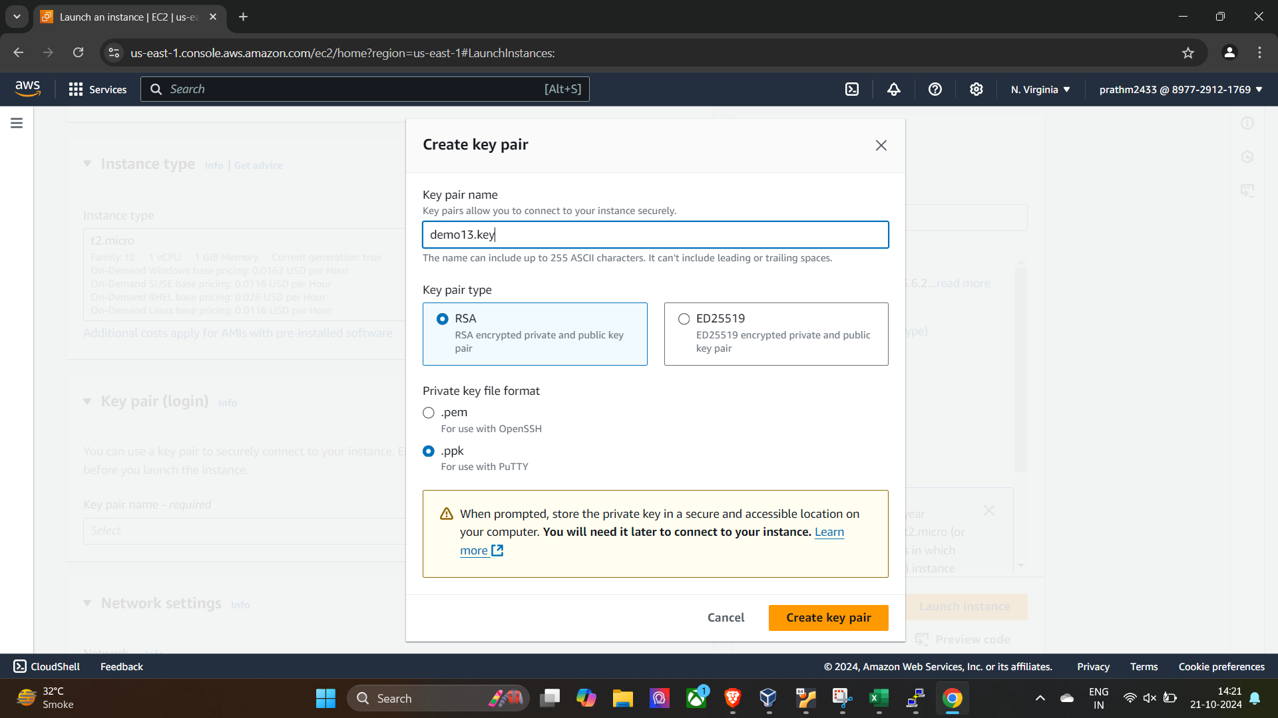

**Instance create in user**

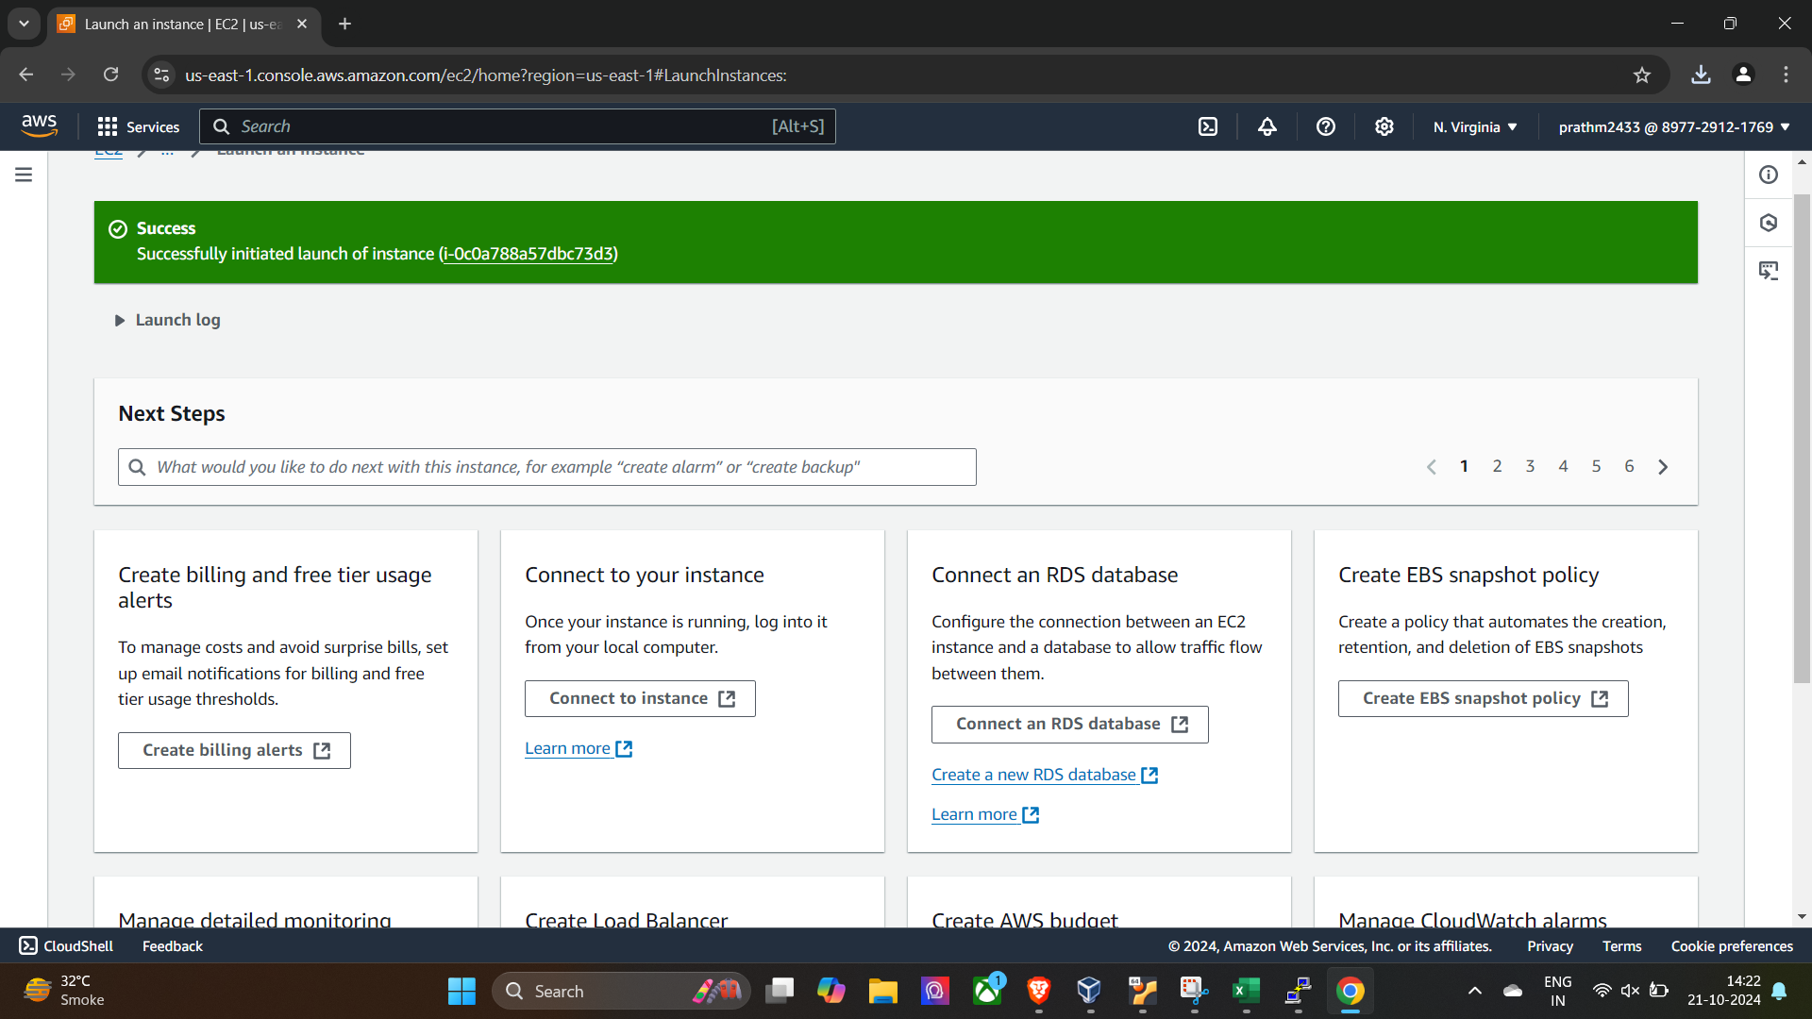

**Copy the public Ipv4 for putty**

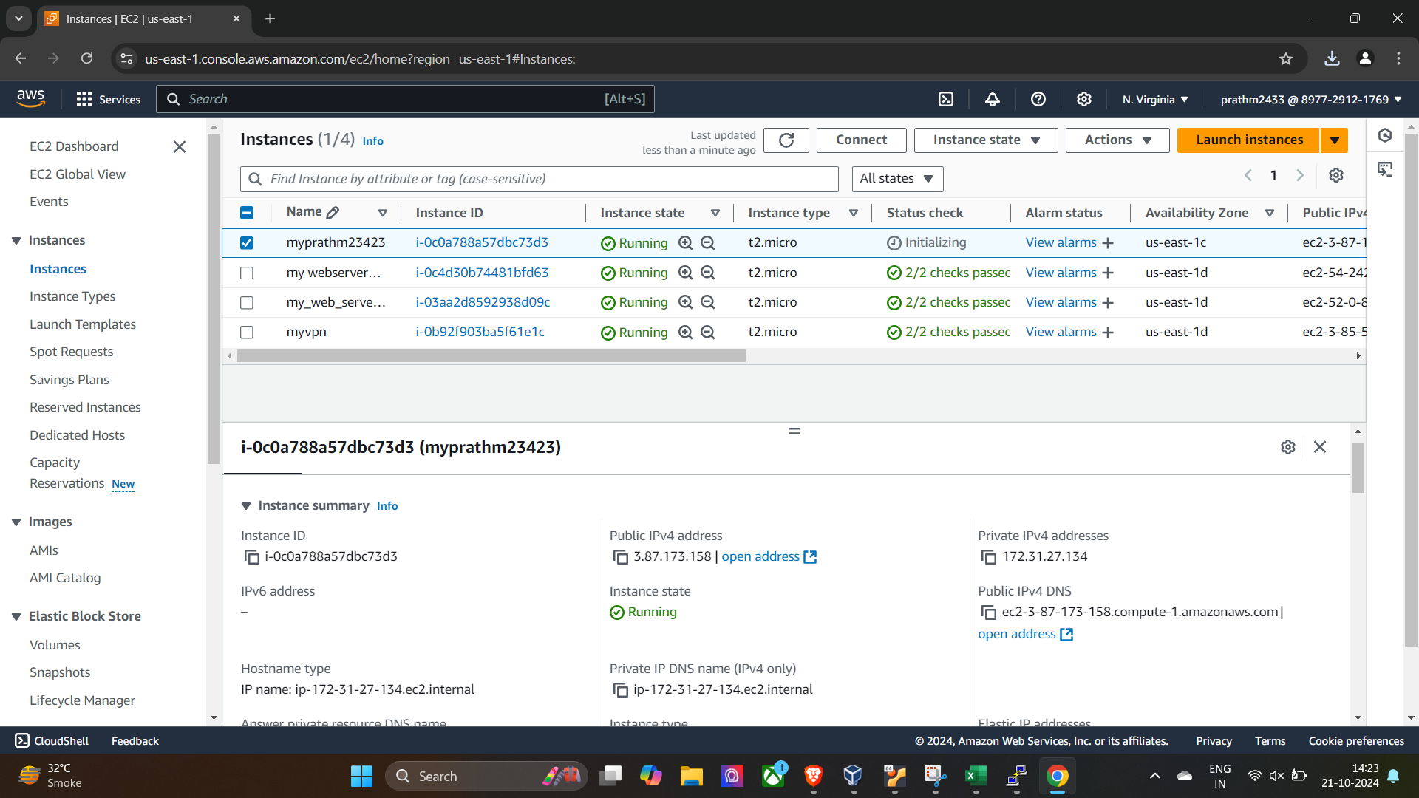

**Copy the ipv4 and paste in putty also select AUTH in putty and select ssh and browse the key**

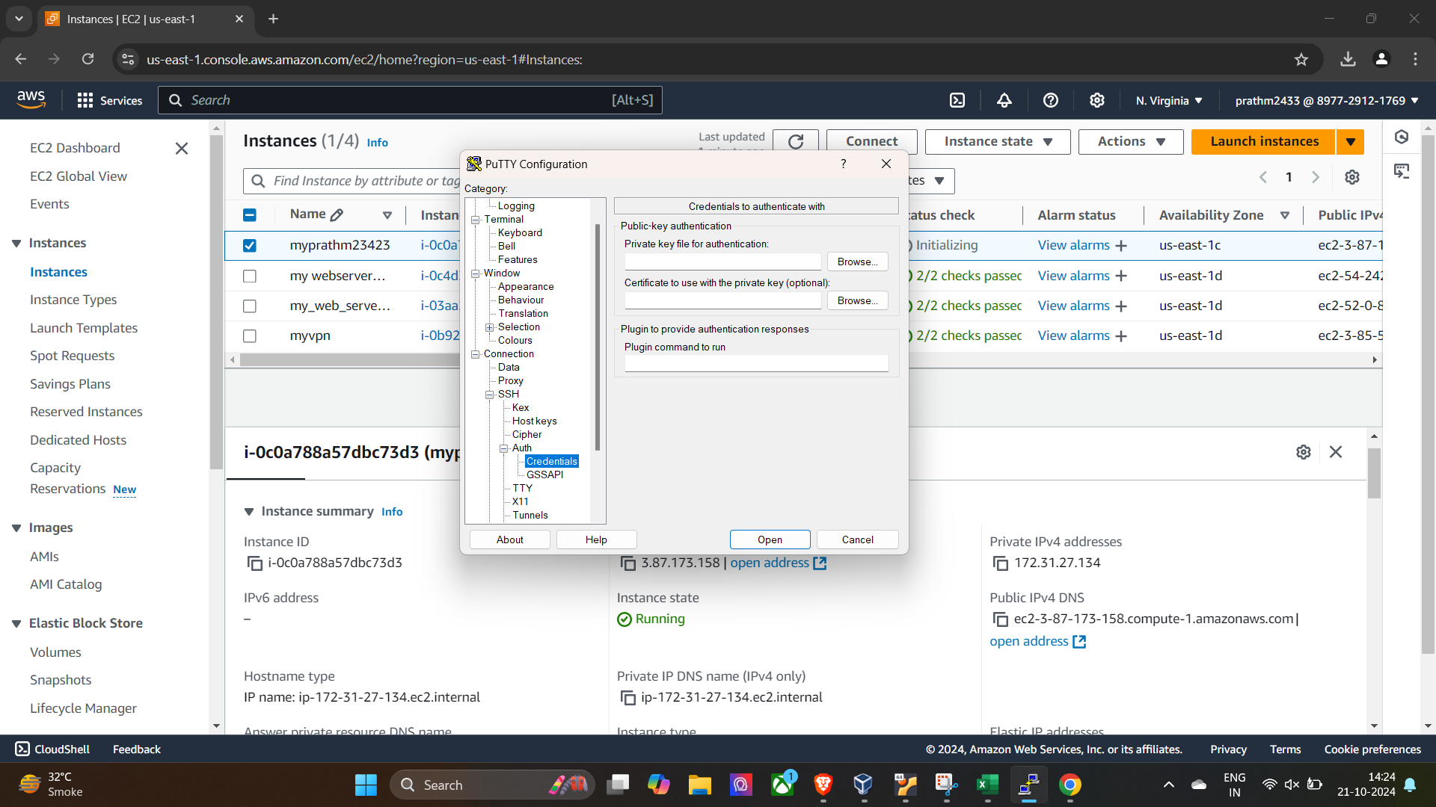

**Open the terminal with use of putty**

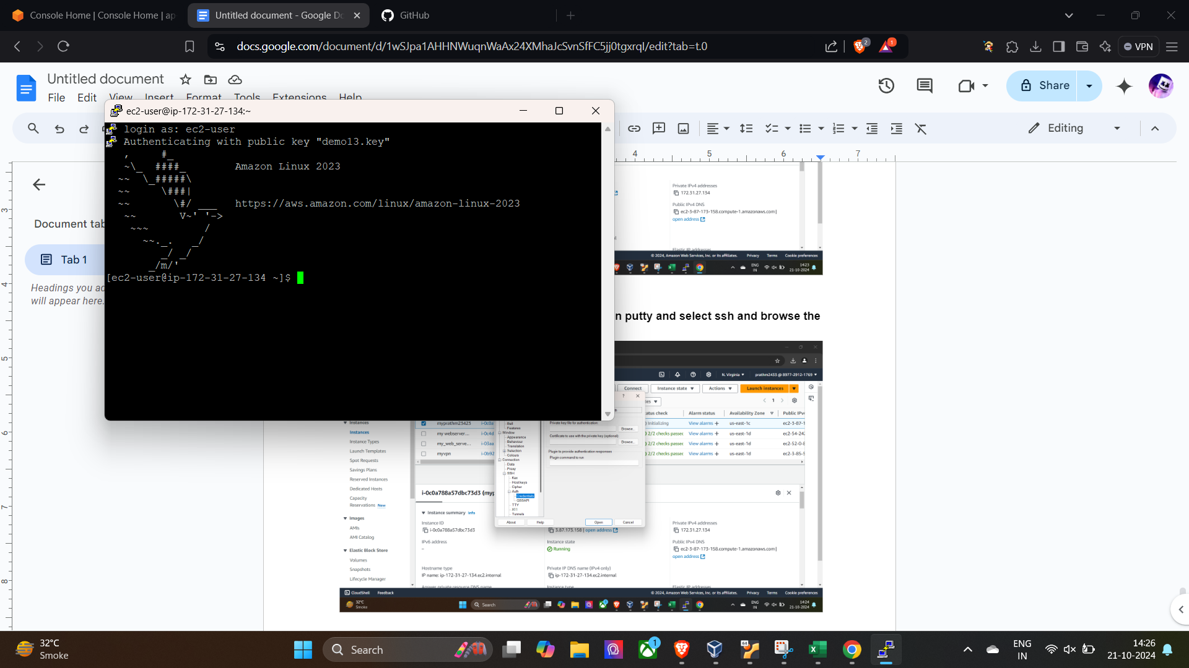

**Give the aws configuration with that access key of user**

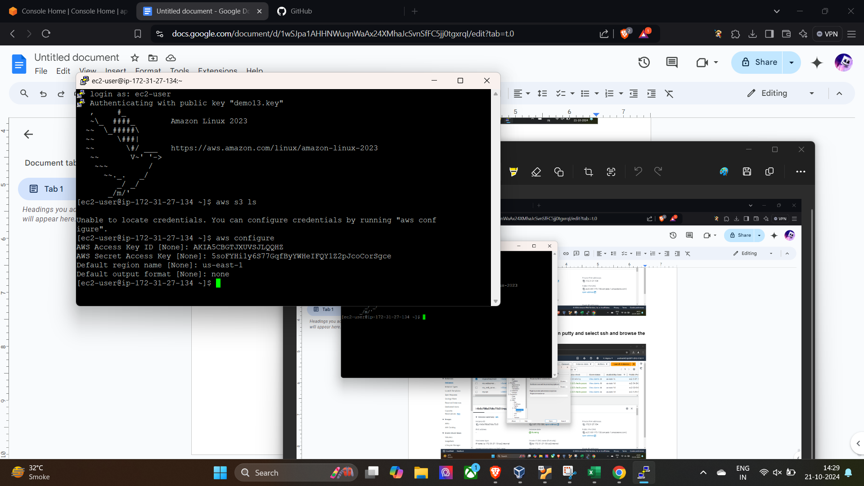

**List of bucket in it and create on html file**

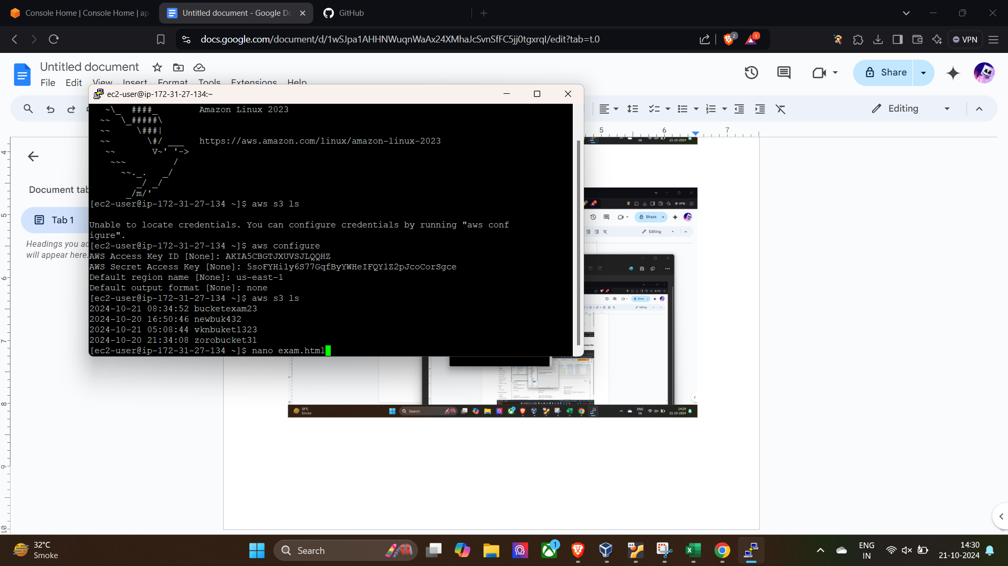

**Create one html file and add data**

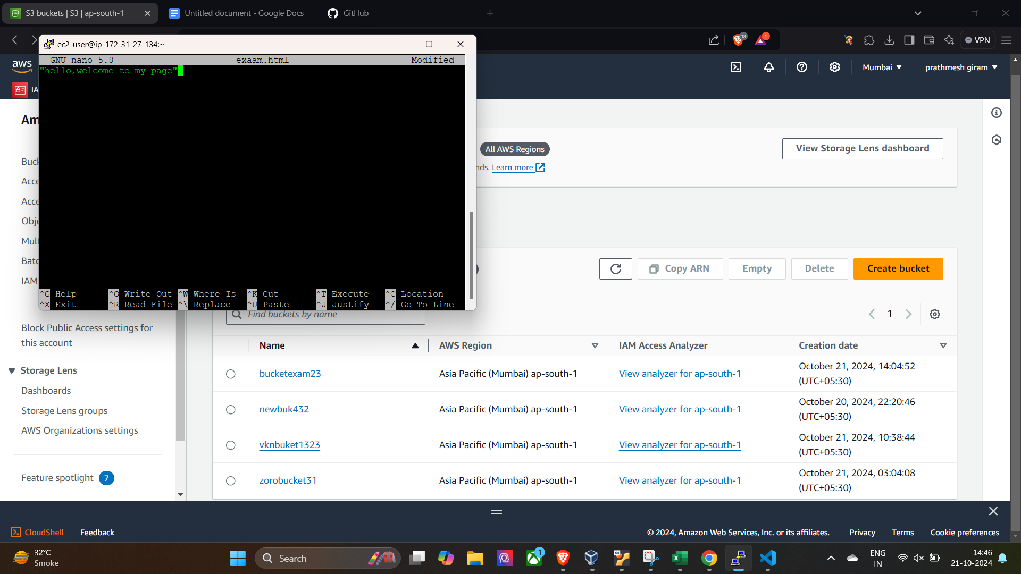

**Upload it in the baucketexam23 via**

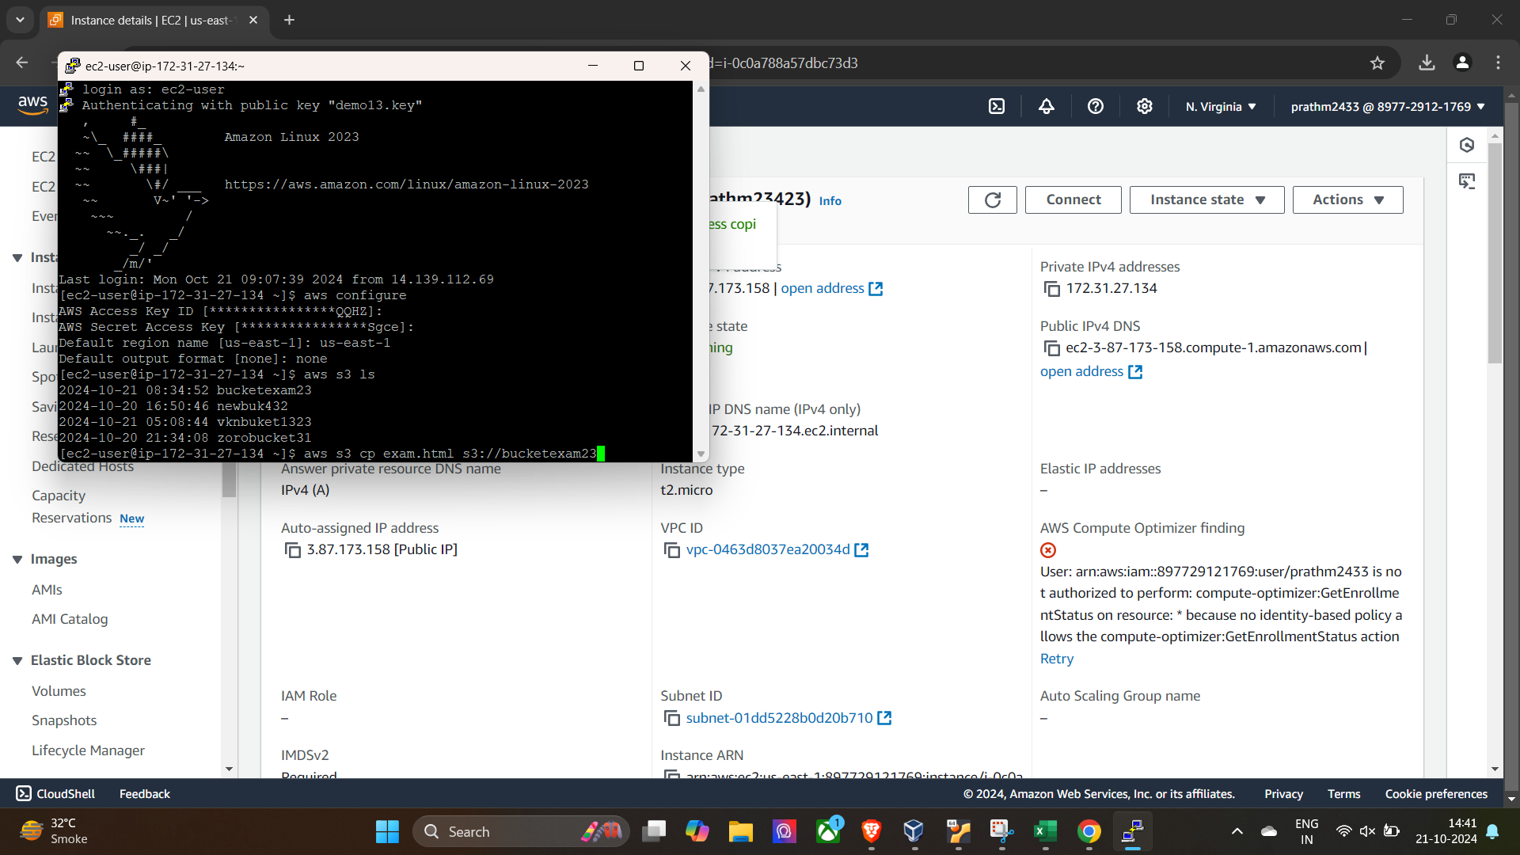

**After upload make public to it access**

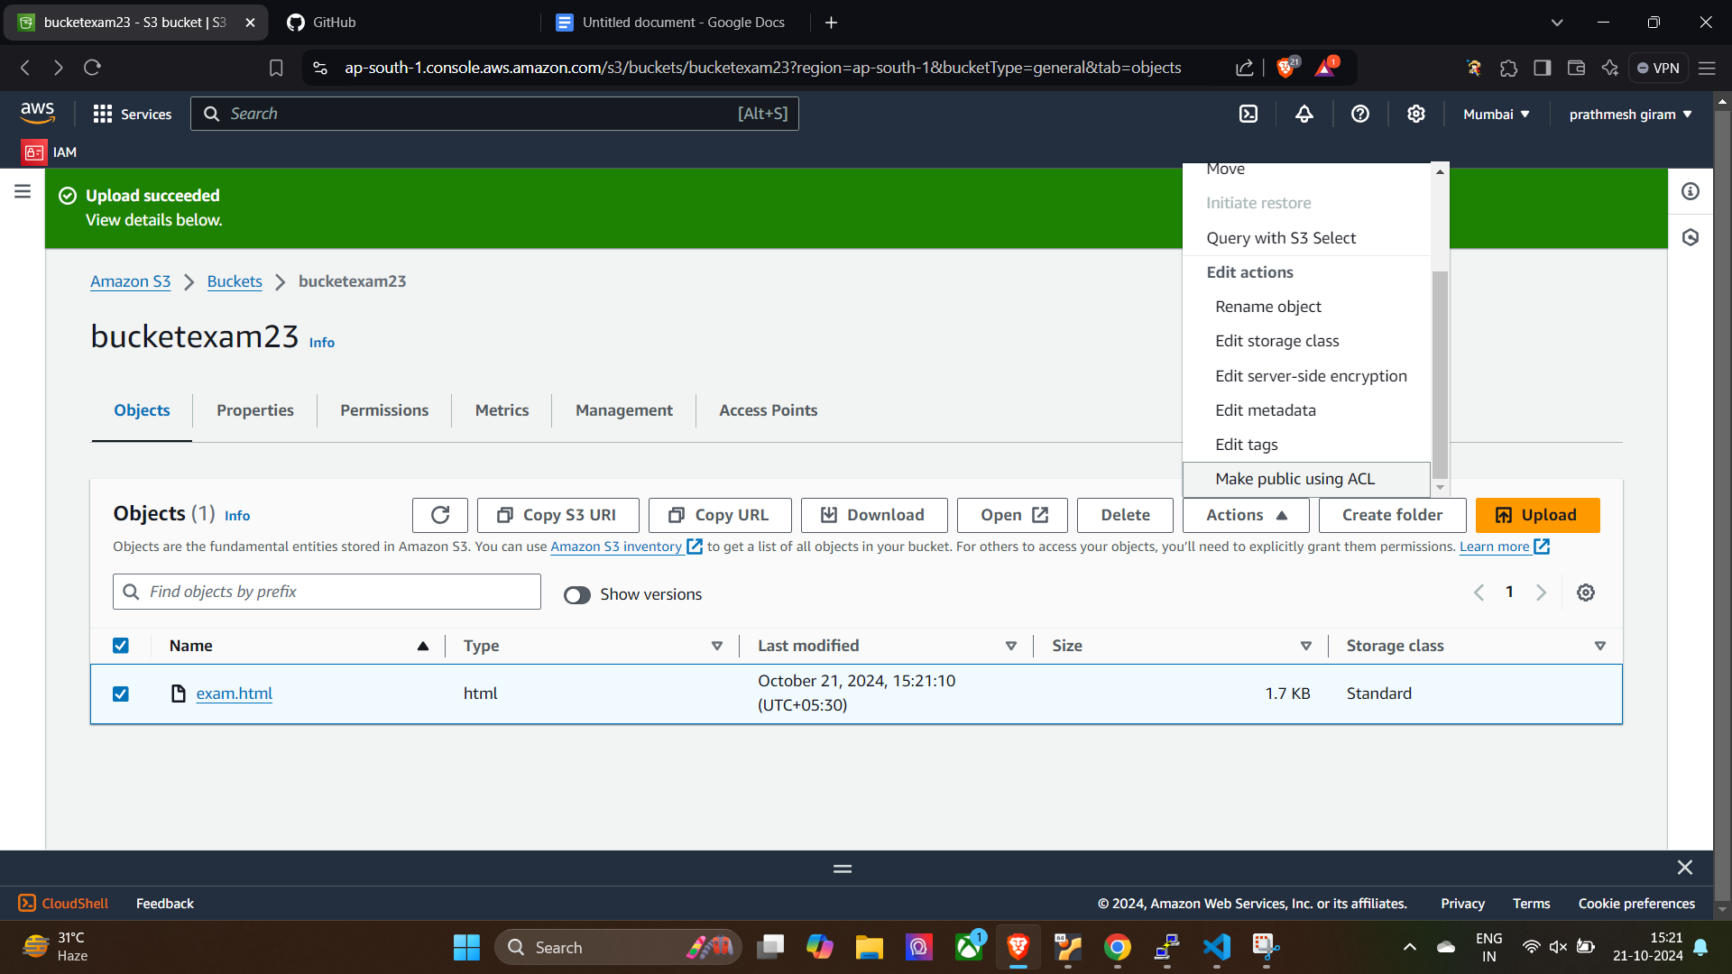

**Linux First question**

**Q 1**

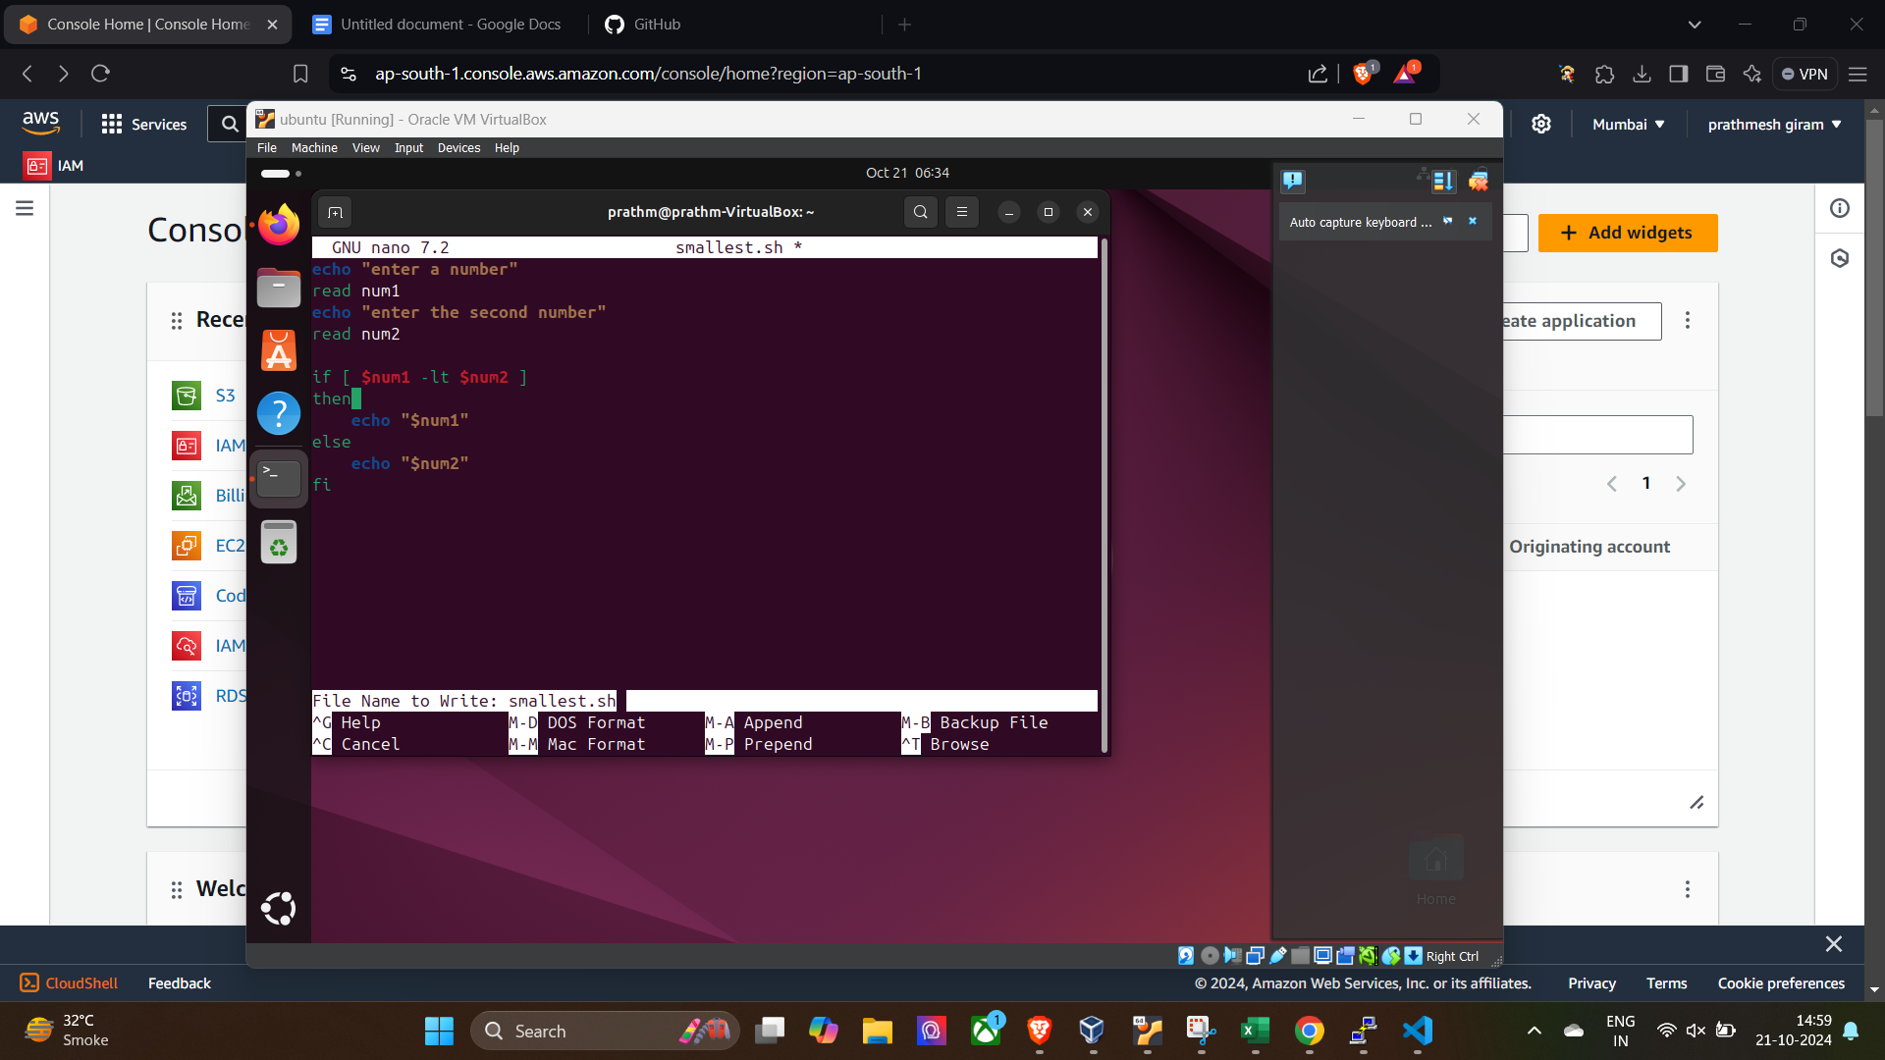

**read num1**

**read num2**

**If [ $num1 -lt $num2 ]**

**then**

**echo “$num1”**

**else**

**echo “$num2”**

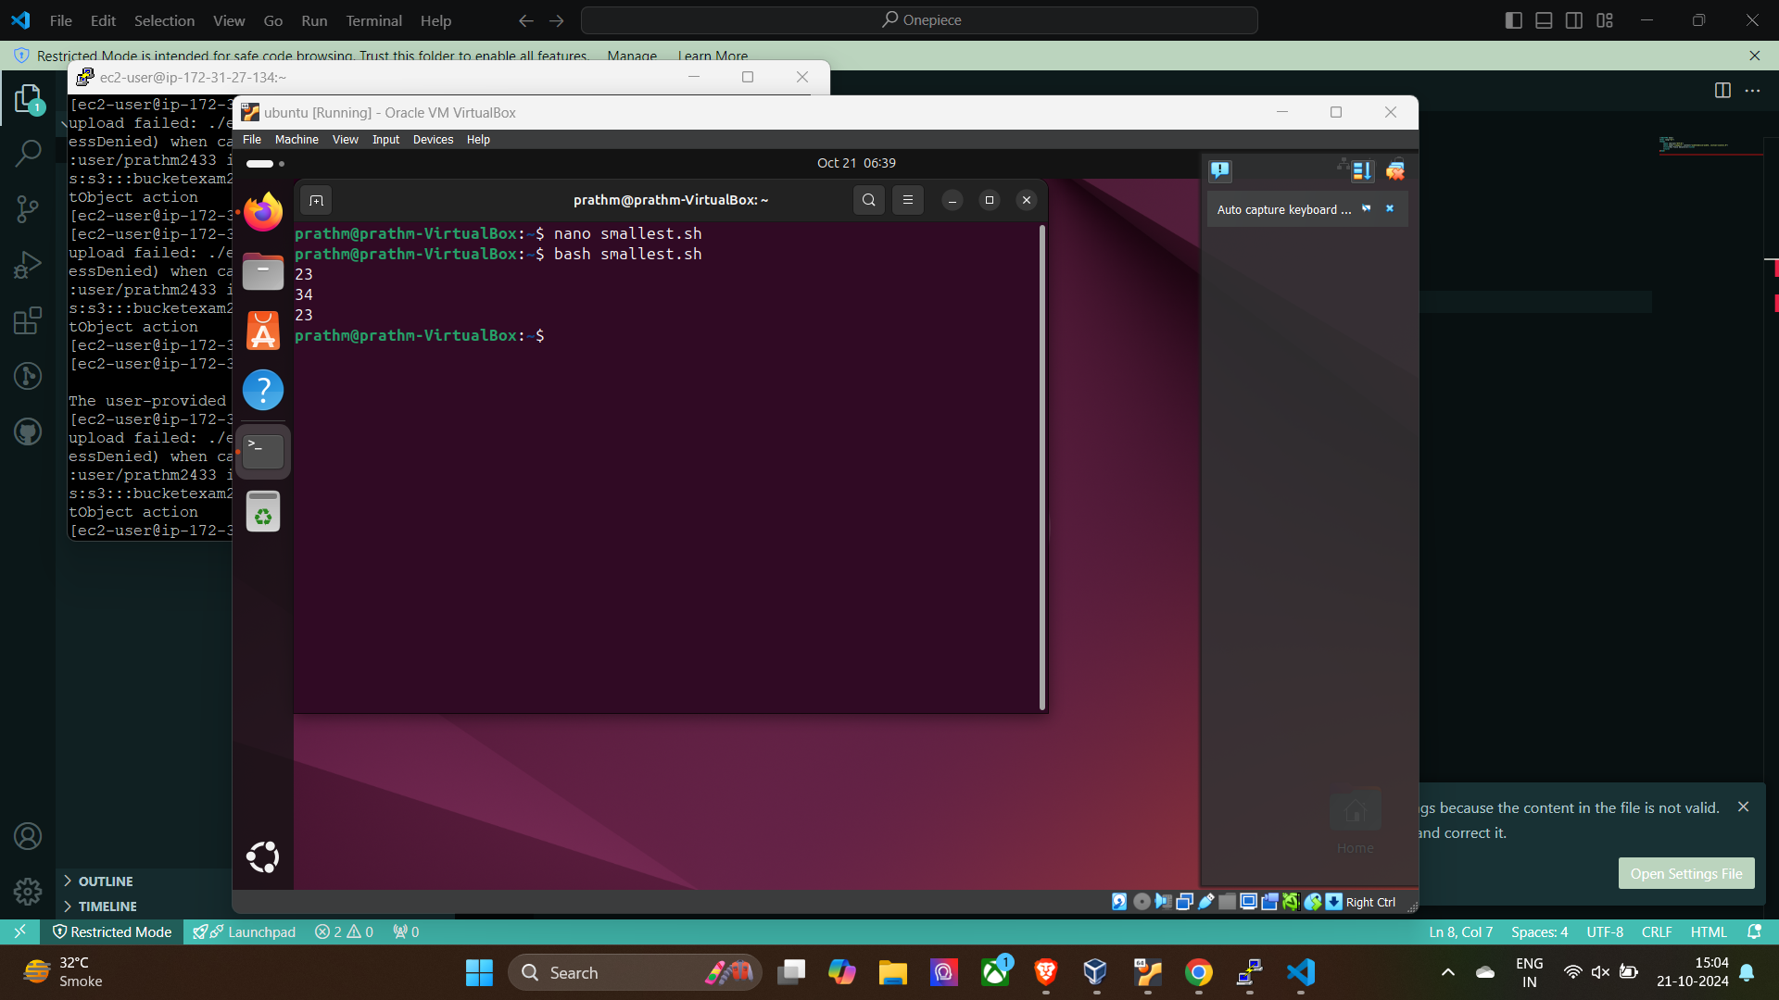

**Question 2**

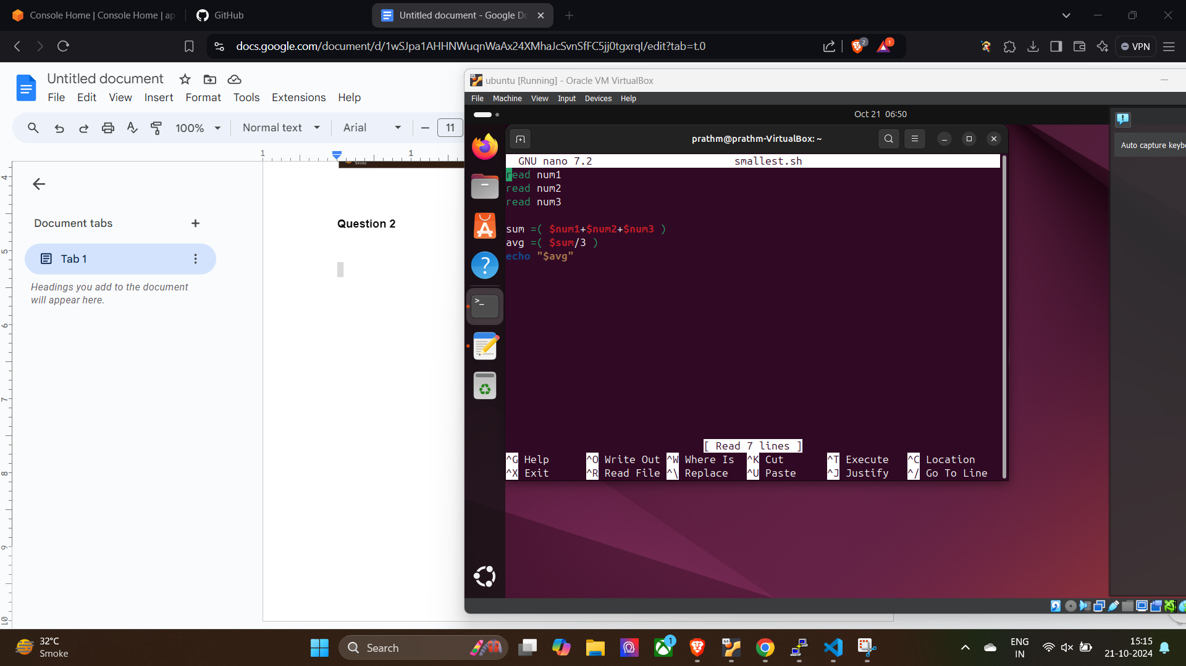

**read num1**

**read num2**

**read num3**

**sum= (($num1+$num2+$num3))**

**avg=(($sum/3))**

**Linux Second question**

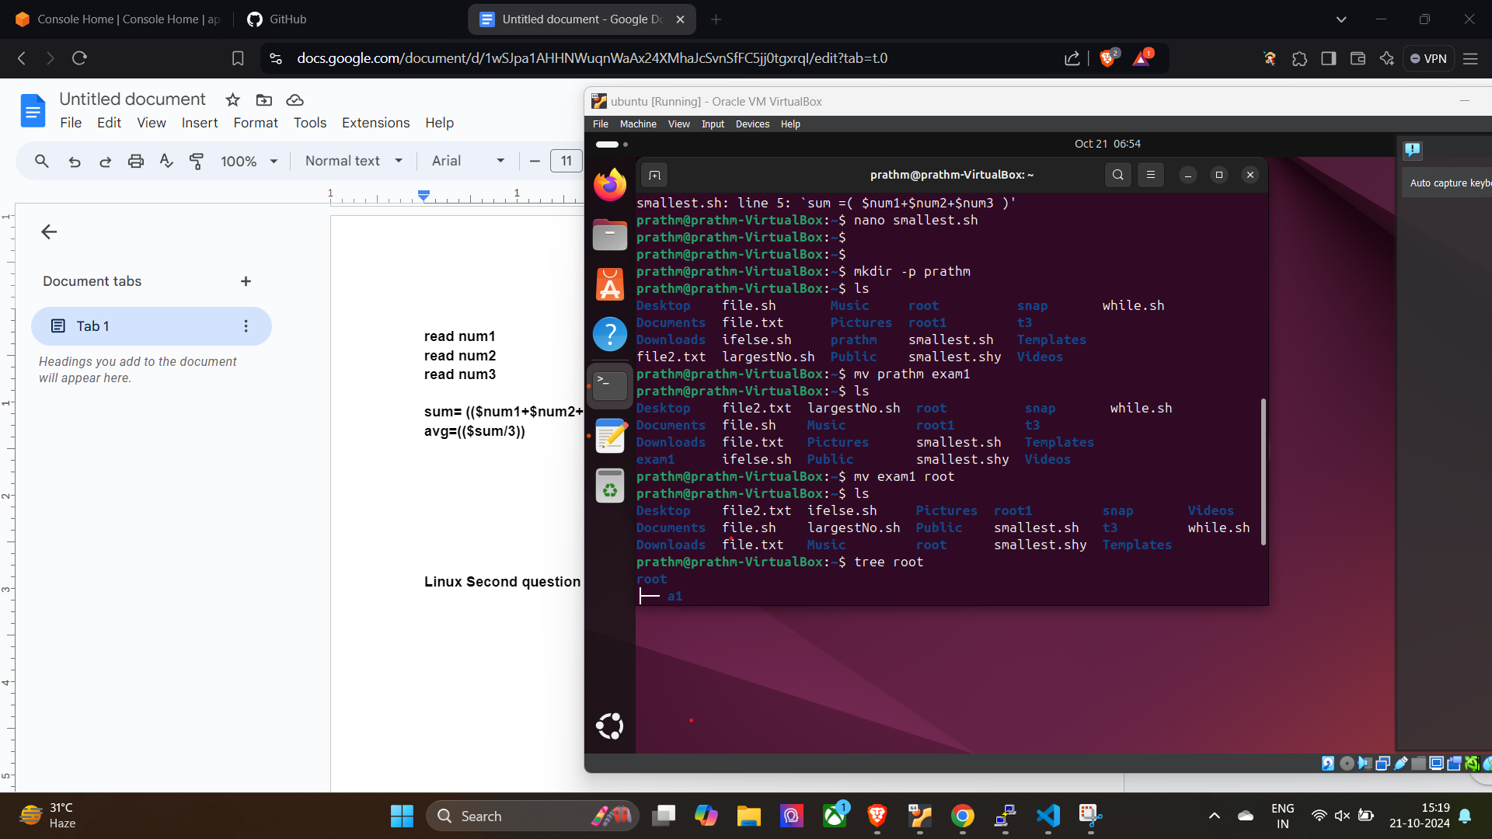

**Remove that file inside of the root name exam1**

